**Methods of Finding Trend**

**1. Graphical**

**2. Statistical -> selected points (AP), semi-averages**

**3. Algebra/Natural method**

**4. Moving averages**

**5. Weighted Moving average**

1. Graphic Method

In this method the key point is assumption of linearity.

We assume simple approach. We are given the graphical presentation of the data. We take two different points on the graph. This becomes subjective; but we do consider such two points that the line joining those two point remains very close to all the points showing the data points. This can be done as follows.

1. Statistical Method
   * selected Points

The central idea is the inserting arithmetic mean between two terms.

Time: t1 t2 t3 t4 t5 t6 t7 t8

Yield : y1 y2 y3 y4 y5 y6 y7 y8

Say we select (t2, y2) and (t7, y7) as fixed points.

Y2 ,……., ………, ………., ………, y7. In between there are four terms to beinserted that all the terms from y2 to y7 takes up the format of an **A.P.**

**Let d**  = ( y7 – y2)/ (n+1) then we have assumption that there is linearity.

Time: t1 t2 t3 t4 t5 t6 t7 t8

Predicted Yield : y1 y2=a a+d a+2d a +3d a +4d y7 =a +5d y8

// d = (l-a)/(n+1) //n+1 = total number of terms including a,l

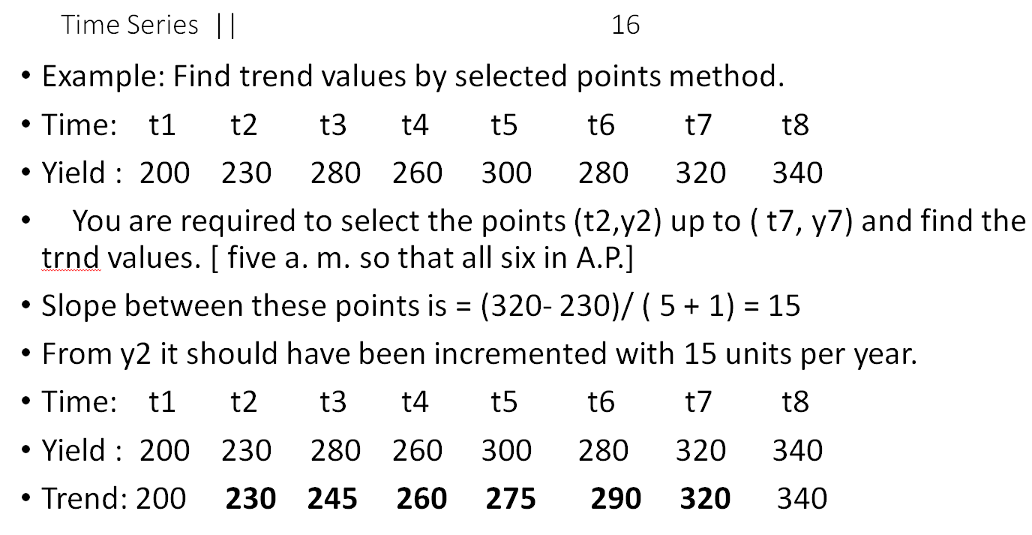

* + **Semi Averages Method: Better than above**

The central idea is same; insert in arithmetic means between two given numbers. There are two types 1) when there are odd number of observation and 2) there are even number of observations.

* Time : 1 2 3 4 5 6 7 **8** 9 10 11 12 13 14 15
* Yield: 10 11 13 8 14 12 9 **14** 13 10 12 16 14 16 17
* Mean: ………… ..….11………………….. ……………………..14 ……………………..
* Trend **11 12.5 14**
* **With incremental factor = ( 14 – 11)/8 = 3/8 [ 11** and 14 remain fixed.] seven terms so that all eight terms in A. P.

// for odd, same as below, either omit middle term, or include it into both sides

* **Semi – Average Method**----- There are even number of observations in the series. Study the table and concentrate on the flow. N = No. of years =10
* Time: 01 02 03 04 05 06 07 08 09 10
* Price: 16 17 18 19 20  **20 22 23 19 21**
* Average: ………………90/5 =18………. …………….105/5= 21…………
* . we have S1 = 90 . And S2 = 105 We assume linear form : y = a + bx
* a = intercept on y axis and b is the slope A of the line. **a = 2 (S1)/ n**
* a = 2 x 90 / 10 = 18 and **b = 4 (S2- S1) / n^2**= 4 ( 105 - 90) / 10^2 = 0.6

// n is total numbe of observations

* We have the linear form y = a + bx. ; where x is an independent variable
* Taking up different values. A + 18 and b = 0.6; y = 18 + 0.6 x
* X : --2 --1 0 1 2 3 4 5 6
* Y : 16.8 17.4 18 18.6 19.2 19.8 20.4 21 21.6 ----Trend
* Given : 16 17 18 19 20 20 22 23 19

For even -> s1 = sum of first n/2 values, s2 next n/2

1. Algebraic Method
   * **Natural method (Algebraic Method)**; It is with an assumption of linearity, or assuming flow of data with quadratic rule, or some other rule– like y = a. b^x

1 y = a + bx 2 y = a + bx + c.x^2 3 y = a. b^x

Where a , b, and c are constants and x is an  **independent variable**

// This is regression analysis

1. Moving Average

27/7

methods -> graphical method -> not perfect

algebric method -> regression analysis

semi-averages (moving averages) -> no. of time needs to be odd

time -> can be adjusted as -3,-2,-1,0,1,... but you cannot adjust Y

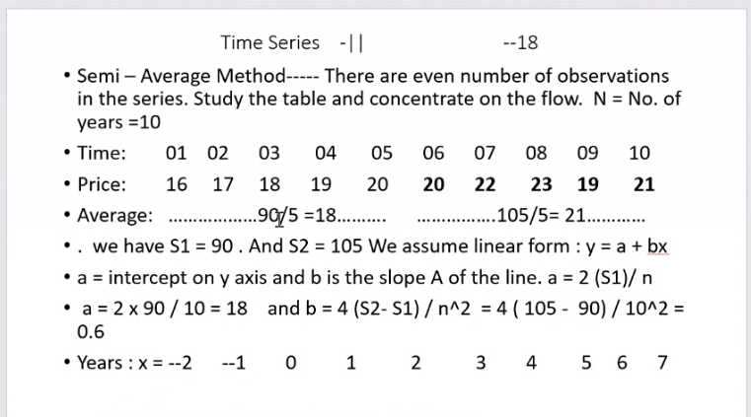

* Fit linear regression
* Fit quadratic: Y = a+bx+cx^2

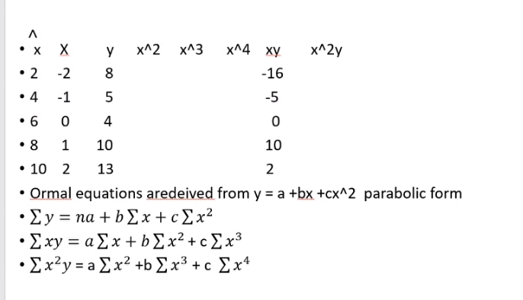

Taking centred X -> makes trend fitting technique easier

Given a question:

* Draw a scatter diagram
* If points in line -> linear assumption
* If quadratic -> quadratic assumptions
* Normal equations -> equations to find out the coefficients

Once a,b,c are identified, you can forecast.

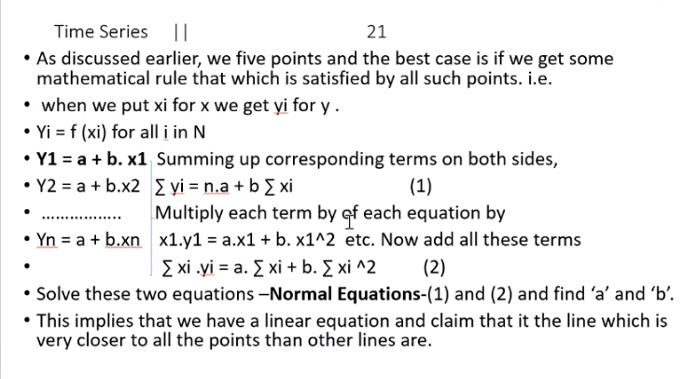

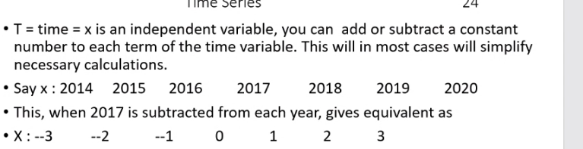

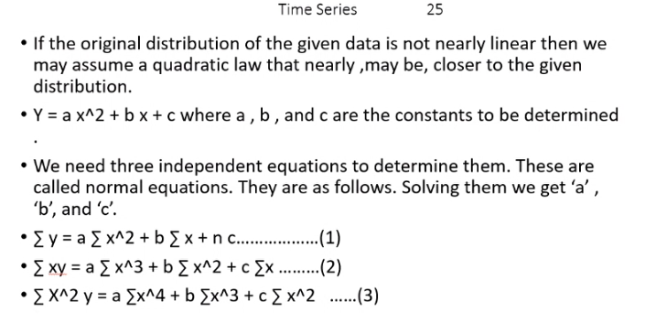

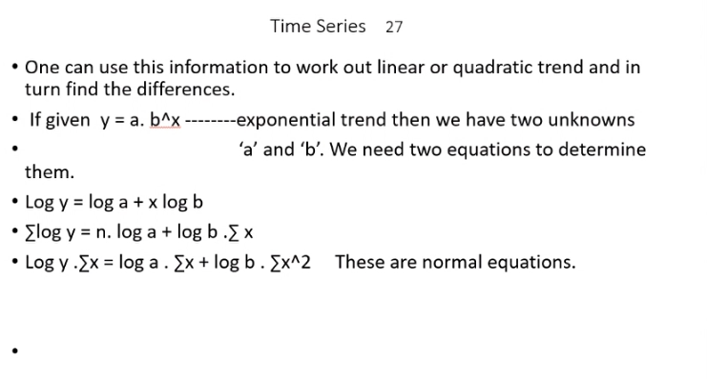

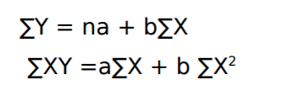

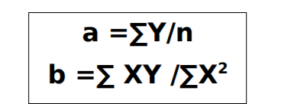

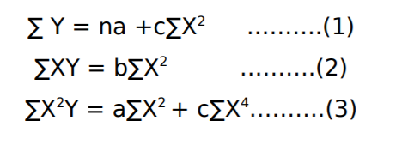

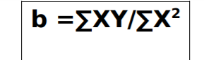

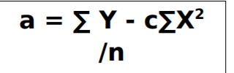

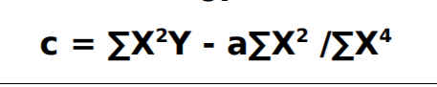

Focus -> find trend -> in general, over long period of time, what is the flow of data

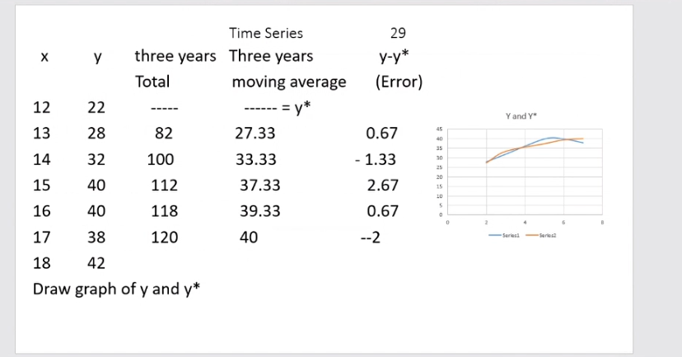

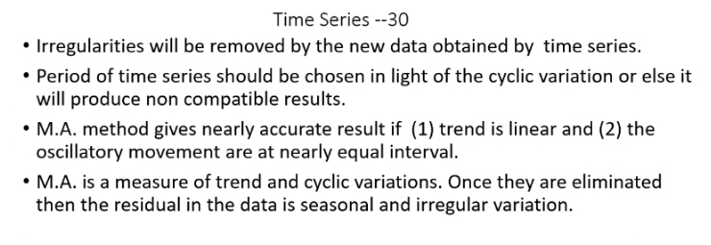

* Usually time period is 3-4. Because using higher periods -> if some time, seasonal or cyclic variation is high, then it’s effect on average will be higher.
* Good only when trend is linear, not good in paralbolic trends.

4 Quaterly moving average:

* Average of 4’s -> write between second and third..
* Leave one above, add on bellow -> write b/w 3,4th
* Centre it further -> write across 3rd quarter…
* Continue. For each quarter

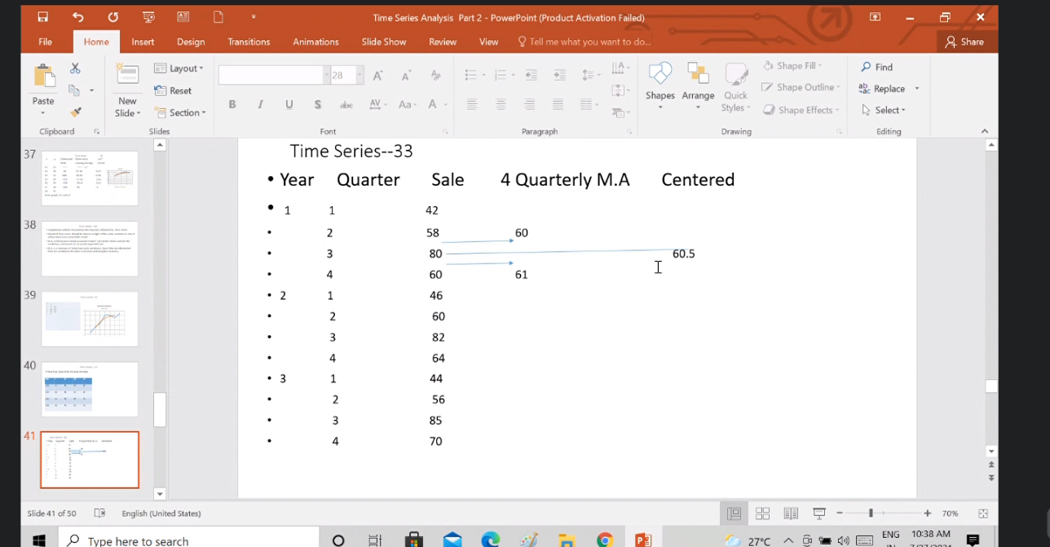

Weighted moving average -> better than above:

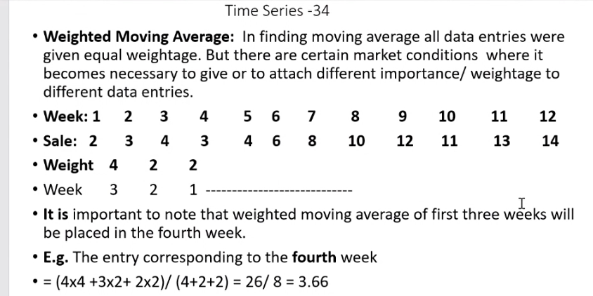

(2,2,4) -> 4 for the just last one.

sum(Y*weight)/sum(weight)